Atomic Project

**Summary of Organization**

**Summary of Organization**

**Step-1: User Story**

* As a user I want to add summary of an organization so that this will show on the list. (C)
* As a user I want to edit summary of an organization so that I can correct any mistakes. (U)
* As a user I want to view the summary of an organization individually. (RS)

**Step2: Use Case**

**Add summary of an organization:**

|  |  |  |
| --- | --- | --- |
| **Requirements** | **Key Features** | **Acceptance Criteria** |
| As a user I want to add summary of an organization so that this will show on the list. | To make a user friendly, Data should be saved without refreshing page. (Ajax) | 1.    User can add summary without any problem.(Core features)  2.    User should see the success/failure message. (Message)  3.    User can enter only letter, number and -,\_. (Format Validation)  4.    Input should be Sanitized to secure the application  (Sanitization)  5.   In case of invalid input JavaScript message should be displayed. (Usability/User Friendly Interface) |

**Edit summary of an organization:**

|  |  |  |
| --- | --- | --- |
| **Requirements** | **Key Features** | **Acceptance Criteria** |
| As a user I want to edit summary of an organization so that I can correct any mistakes. | To make a user friendly, Data should be saved without refreshing page. (Ajax) | 1.     User can edit the summary without any problem.(Core features)  2.     User should see the success/failure message. (Message)  3.     User can enter only letter, number and -, \_. (Format Validation)  4.     Input should be Sanitized to secure the application  (Sanitization)  5.     In case of invalid input JavaScript message should be displayed. (Usability/User Friendly Interface) |

**View summary of an organization (individually):**

|  |  |  |
| --- | --- | --- |
| **Requirements** | **Key Features** | **Acceptance Criteria** |
| As a user I want to view the summary of an organization individually. |  |  |

**User Friendly Navigation:**

|  |  |  |
| --- | --- | --- |
| **Requirements** | **Key Features** | **Acceptance Criteria** |
| As a user I want to have user friendly navigation so that I can browse the site easily. |  | 1.    There should be one button at the bottom of add form. **(A. Add)**  **A)** User should see the summary of an organization if clicked on “Add” button.  2.    User should see the summary of an organization after edit/update info. |

**Step 3: Robustness Diagram**

**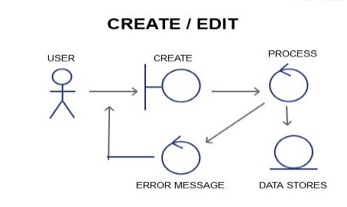**

**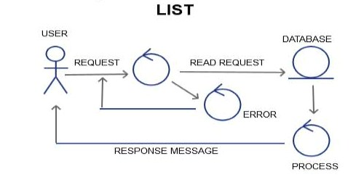**

**Class Diagram:**

**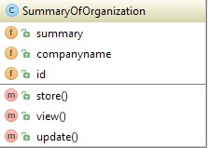**

**Sequence Diagram:**

**Create/Add/Edit**

**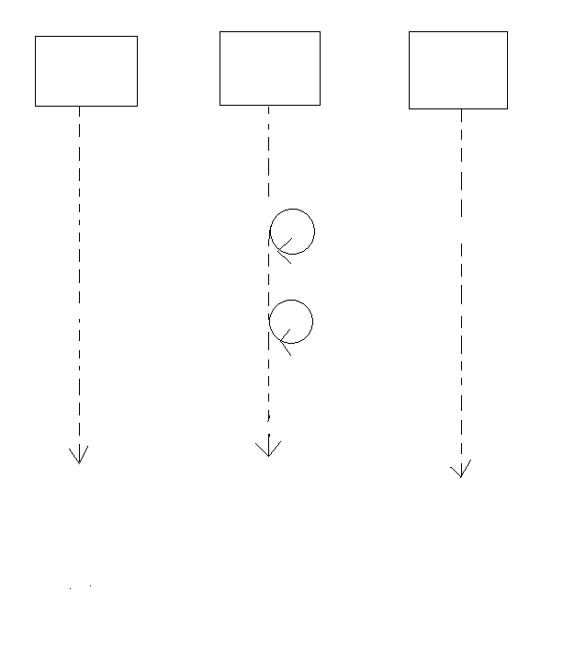**

Response Message

Storing Data to DB

Sanitization

Validation failure

Add Request

DATABASE

PROCESS

USER/GUI

Format Validation

**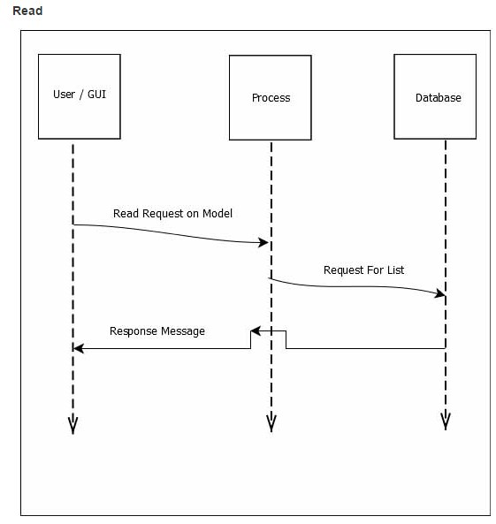**

#### Schema Diagram:

#### F:\xampp\htdocs\atomic_project_rumpa_136509_b34\Atomic project b34\Schema diagram\summaryoforganization.JPG

#### Mockup:

#### Add:

#### 

#### Edit:

#### 

#### View:

#### 